- Revision Bottleneck + SE:
- Confusion Matrix:
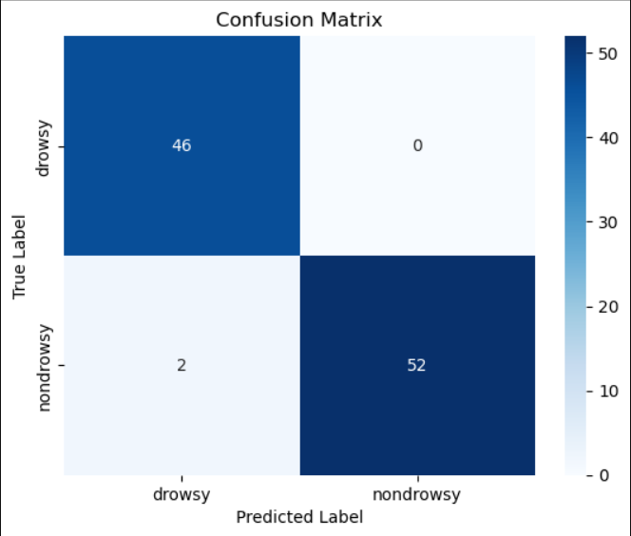
- Classification Report:
 | precision | recall | f1-score | support
Drowsy | 0.96 | 1.00 | 0.98 | 46
Nondrowsy | 1.00 | 0.96 | 0.98 | 54
accuracy |  |  | 0.98 | 100
macro avg | 0.98 | 0.98 | 0.98 | 100
weighted avg | 0.98 | 0.98 | 0.98 | 100
- Loss:
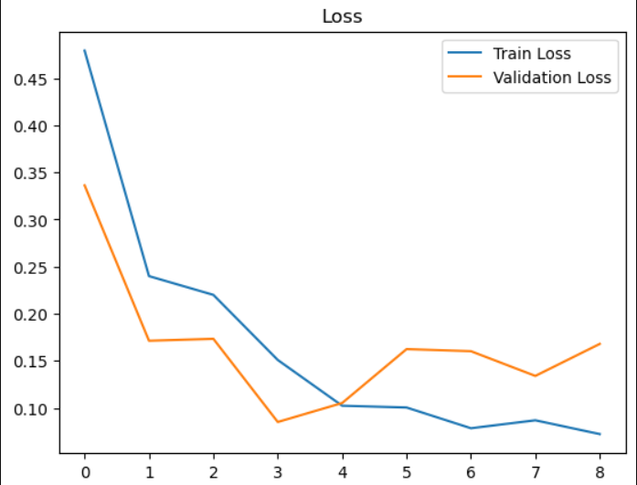
- Accuracy:
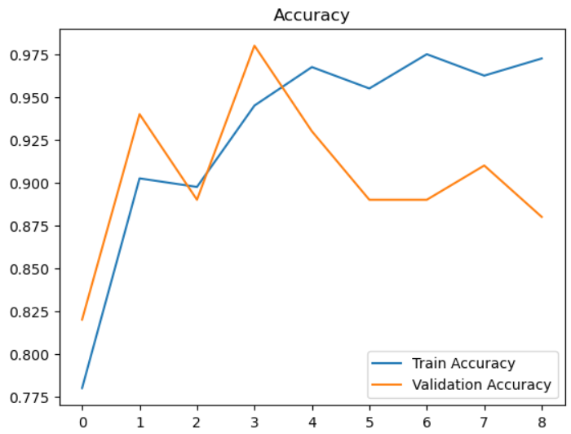
- Preprocessing
- Resizing all images to: (150, 150) pixels.
- Pixel normalization to: Range [0, 1].
- Random augmentation: Rotation (20), Horizontal Flip, Width Shift (0.1), Height Shift (0.1), Shear (0.1), and Zoom (0.1).
- Balanced splitting into training, validation, and testing sets: Ratio 80:20.
- Training Configuration
- Optimizer: Adam
- Learning rate: 0.001
- Batch size: 32
- Epochs: 30 (Bisa berhenti lebih awal karena ada EarlyStopping).
- Loss function: Categorical Crossentropy
- Weight initialization: ImageNet
- Regularization: Dropout (0.5), BatchNormalization, dan Early Stopping.
- Additional:
Metric | Value
Params | 2,628,562 parameters
FLOPs | 315,874,140 Ops
Model Size | 13.39 MB
Latency | 206.2658 ms

* Model stabil namun untuk val accuracy kurang stabil karena banyaknya layer

- Revision Bottleneck
- Confusion Matrix:
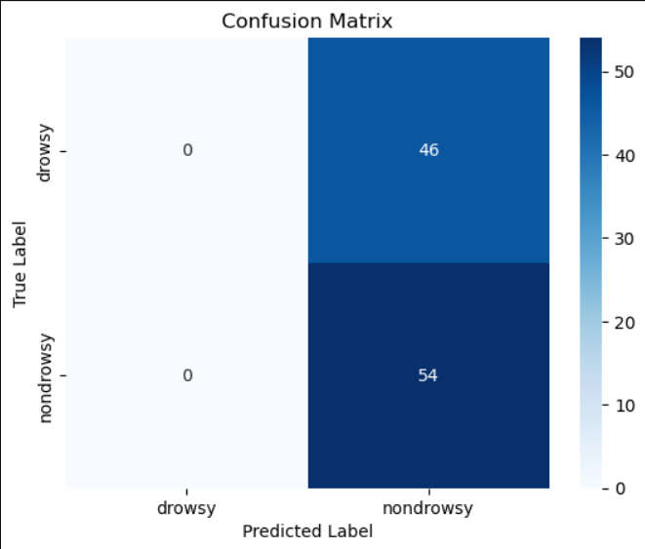
- Classification Report:
 | precision | recall | f1-score | support
Drowsy | 0.00 | 0.00 | 0.00 | 46
Nondrowsy | 0.54 | 1.00 | 0.70 | 54
accuracy |  |  | 0.54 | 100
macro avg | 0.27 | 0.50 | 0.35 | 100
weighted avg | 0.29 | 0.54 | 0.38 | 100
- Loss:
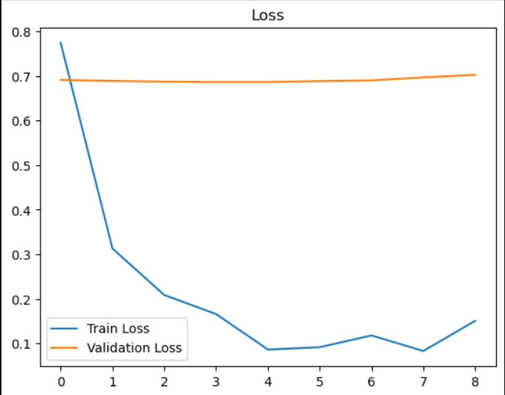
*Terkena earlystop karena nilai validation tidak meningkat (hanya jalan 8 epoch)
- Accuracy:
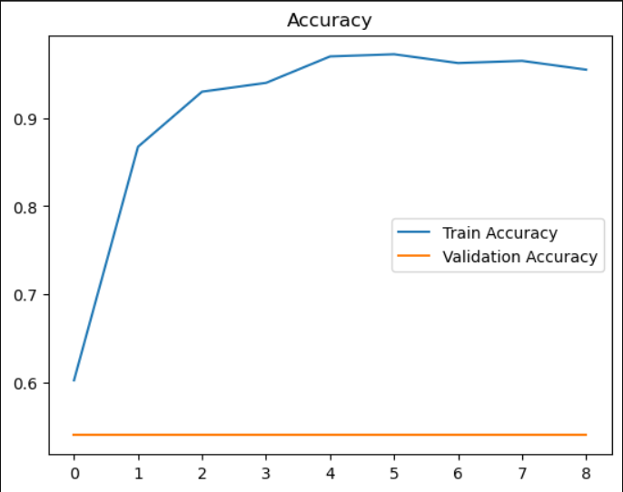
*Terkena earlystop karena nilai validation tidak meningkat (hanya jalan 8 epoch)

- Preprocessing
- Resizing all images to: (150, 150) pixels.
- Pixel normalization to: Range [0, 1].
- Random augmentation: Rotation (20), Horizontal Flip, Width Shift (0.1), Height Shift (0.1), Shear (0.1), and Zoom (0.1).
- Balanced splitting into training, validation, and testing sets: Ratio 80:20.
- Training Configuration
- Optimizer: Adam
- Learning rate: 0.001
- Batch size: 32
- Epochs: 30 (Bisa berhenti lebih awal karena ada EarlyStopping).
- Loss function: Categorical Crossentropy
- Weight initialization: ImageNet
- Regularization: Dropout (0.5), BatchNormalization, dan Early Stopping.
- Additional:
Metric | Value
Params | 3,444,616 parameters
FLOPs | 354,567,062 Ops
Model Size | 22.59 MB
Latency | 206.9936 ms

*Model tidak stabil (Terkadang bisa akurasi sangat tinggi & bisa sangat rendah)

- Revision DSC + Bottleneck
- Confusion Matrix:
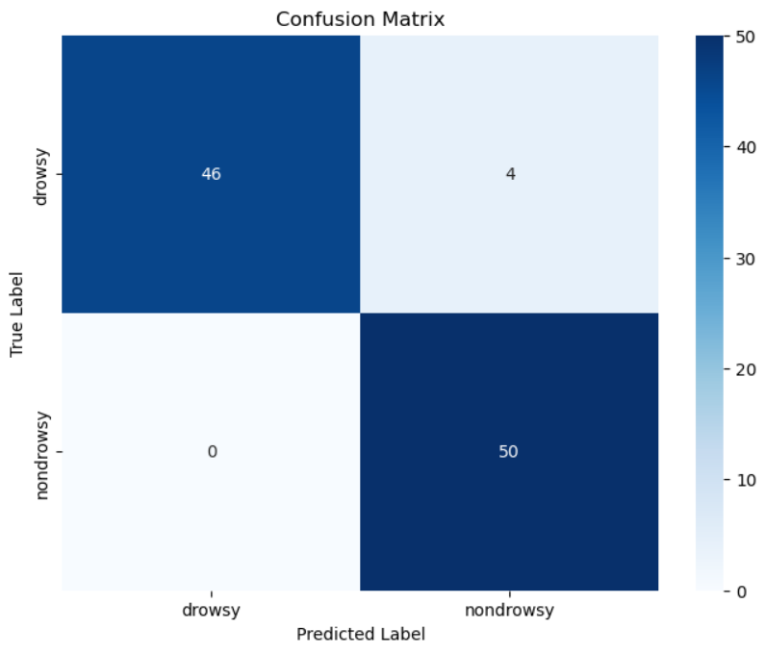
- Classification Report:
 | precision | recall | f1-score | support
Drowsy | 1.00 | 0.92 | 0.96 | 50
Nondrowsy | 0.93 | 1.00 | 0.96 | 50
accuracy |  |  | 0.96 | 100
macro avg | 0.96 | 0.96 | 0.96 | 100
weighted avg | 0.96 | 0.96 | 0.96 | 100
- Loss:
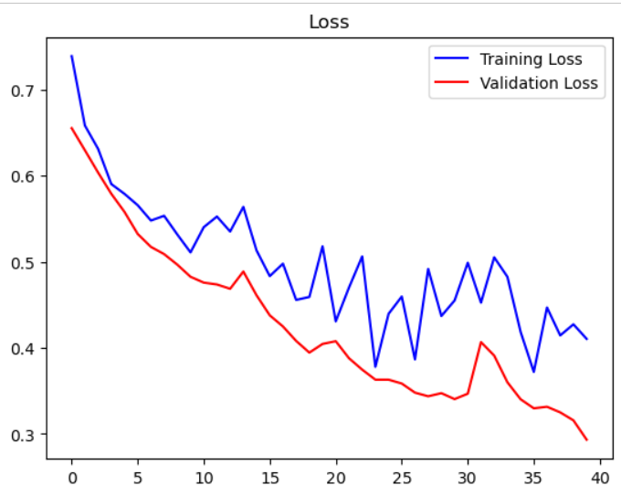
- Accuracy:
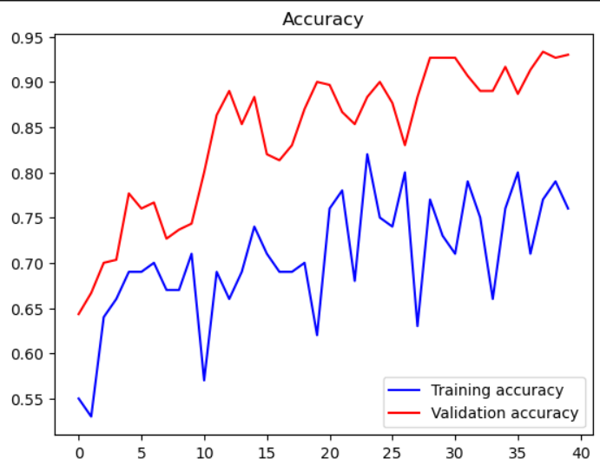
- Preprocessing
- Resizing all images to: (150, 150) pixels.
- Pixel normalization to: Range [0, 1].
- Random augmentation: Rotation (20), Horizontal Flip, Width Shift (0.1), Height Shift (0.1), Shear (0.1), and Zoom (0.1).
- Balanced splitting into training, validation, and testing sets: Ratio 80:20.
- Training Configuration
- Optimizer: Adam
- Learning rate: 0.001
- Batch size: 32
- Epochs: 40 (Bisa berhenti lebih awal karena ada EarlyStopping).
- Loss function: Categorical Crossentropy
- Weight initialization: ImageNet
- Regularization: Dropout (0.5), BatchNormalization, dan Early Stopping.
- Additional:
Metric | Value
Params | 2,263,118 parameters
FLOPs | 299,409,632 Ops
Model Size | 9.03 MB
Latency | 178.8733 ms

*Model mulai lebih stabil namun val accuracy masih belum bisa mengimbangi Train accuracy

- Revision Dsc + Bottleneck + Expansion
- Confusion Matrix
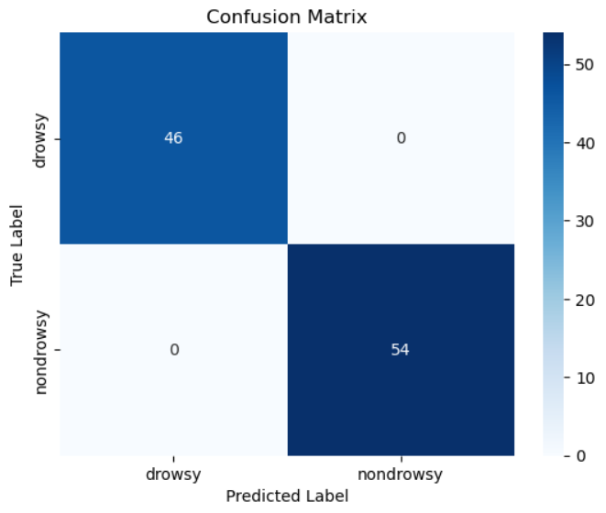
- Classification Report
 | precision | recall | f1-score | support
Drowsy | 1.00 | 1.00 | 1.00 | 46
Nondrowsy | 1.00 | 1.00 | 1.00 | 54
accuracy |  |  | 1.00 | 100
macro avg | 1.00 | 1.00 | 1.00 | 100
weighted avg | 1.00 | 1.00 | 1.00 | 100

- Loss
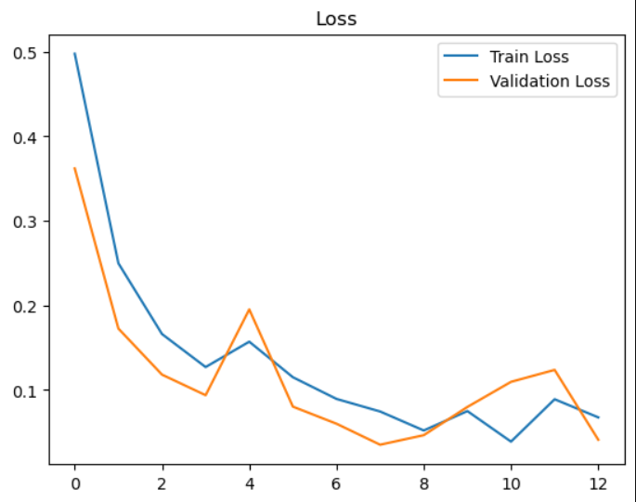
- Accuracy
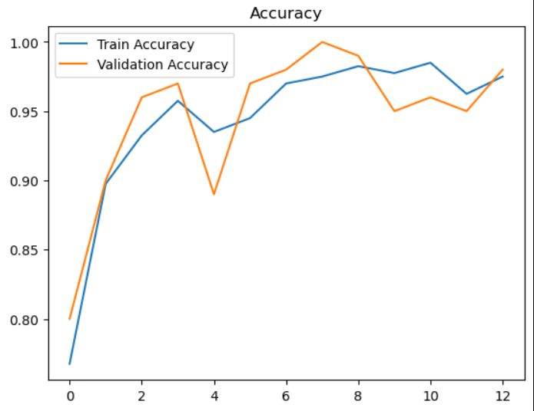
- Preprocessing
- Resizing all images to: (150, 150) pixels.
- Pixel normalization to: Range [0, 1].
- Random augmentation: Rotation (20), Horizontal Flip, Width Shift (0.1), Height Shift (0.1), Shear (0.1), and Zoom (0.1).
- Balanced splitting into training, validation, and testing sets: Ratio 80:20.
- Training Configuration
- Optimizer: Adam
- Learning rate: 0.001
- Batch size: 32
- Epochs: 30 (Bisa berhenti lebih awal karena ada EarlyStopping).
- Loss function: Categorical Crossentropy
- Weight initialization: ImageNet
- Regularization: Dropout (0.5), BatchNormalization, dan Early Stopping.
- Additrional
Metric | Value
Params | 2,620,098 parameters
FLOPs | 315,844,684 Ops
Model Size | 13.12 MB
Latency | 143.6521 ms

*Model lebih stabil dan train serta val accuracy saling mengimbangi; Akurasi paling tinggi

